2020 Columbia Heights/Mount Pleasant Main Street
Small Business Grants
APPLICATION GUIDELINES
SUMMARY

District Bridges’ Columbia Heights/Mount Pleasant Main Street (CHMPMS) program will provide a grant of up to $4,000 for small businesses in the Main Street corridor. Only businesses located on the Columbia Heights/Mount Pleasant Main Street boundary are eligible to apply (see map, below). Funds can be used for technical assistance, exterior and storefront improvements, interior renovations, security improvements and/or equipment. Applications are due Friday, January 31, 2020, 5:00pm. Awards will be made February 14, 2020. All project activities must be completed by August 28, 2020. Please read the guidance for information on how to apply. If you have any questions or need guidance on preparing the application, please contact Carolina Buitrago, Neighborhood Director of the CHMPMS, at Carolina@districtbridges.org.

APPLICATION PROCESS

Applications are available in English and Spanish on the District Bridges’ website (www.districtbridges.org) or by sending a request to Carolina@districtbridges.org. The maximum grant amount awarded is $4,000.

Information sessions for all interested applicants will be held on Thursday, December 19, 2019 at 9:30am (English) and 10:30am (Spanish) and on Wednesday, January 8, 2020 at 1:30pm (English) and at 2:30pm (Spanish). The sessions will be at the District Bridges office, 3400 11th Street NW #200 (upstairs), Washington, DC, 20010. If applicants are unable to walk upstairs, special accommodations can be made upon request.

Businesses can submit their completed applications via email to Carolina@districtbridges.org. If the applicant is unable to submit all documents via email, they can contact Carolina Buitrago to make alternative arrangements.

Applications must be received no later than Friday, January 31, 2020 by 5:00pm.

Applicants will be notified of their award status no later than Friday, February 14, 2020.
CONFIDENTIALITY: Information provided as a part of this grant application shall only be used in evaluating the proposed project. The information will not be made public or shared with any government entity.

SITE VISIT
District Bridges staff will be conducting site visits to all grantees between April and May to evaluate progress for project implementation. Grantees will be informed in advance of the exact date of the site visit. A final site visit will be made upon project completion of the funded project in coordination with the business owner but no later than August 28, 2020.

GRANT FINAL REPORT
The grant period for each grant is approximately six months from the date of the award. All funds must be expended and reported with documentation submitted to District Bridges upon completion of the funded project but no later than Friday, August 28, 2020. The Grantees final report should include:
- Brief description of completed project.
- Copies of receipts, including cancelled checks, credit card receipts, and/or paid invoices for all grant expenditures.
- If applicable: Before and After photos of improvements funded by the grant,

Any funds not expended as proposed by Friday, August 28, 2020, must be returned to District Bridges for reallocation to support other small businesses in the Columbia Heights/Mount Pleasant Main Street.

APPLICANT ELIGIBILITY REQUIREMENTS

To qualify for a grant, the applicant must:
- Be incorporated in the District of Columbia, demonstrated by a current business license.
- Have at least 2 years left in your lease - Will need to submit a copy of your lease. If you own your property you will need to provide proof of ownership.
- Be located within the boundaries of the Columbia Heights/Mount Pleasant Main Street. See map below and confirm eligibility using your business address here.
- Submit a complete application and copy of Business License by the deadline of January 31, 2020, 5:00pm.

District Bridges will not provide a grant to any of the following types of entities:
- Adult entertainment
- Gas stations
- Banks
- Home-based businesses
- Any organization that discriminates against individuals on the basis of race, color, religion, sex, national origin, age, marital status, personal appearance, sexual orientation, family responsibilities, political affiliation, physical handicap, or any other protected class under the DC Human Rights Act and/or any federal anti-discrimination statute or regulation
- Churches and nonprofit organizations
- District of Columbia government agencies
` `

PROJECT ELIGIBILITY REQUIREMENTS

Funds can be used for technical assistance, exterior and storefront improvements, interior renovations, security improvements and/or equipment. The combined amount requested for funding cannot exceed $4,000. Note that each business is responsible for determining DC government permit or licensing requirements and obtaining required permissions prior to beginning the project.

Technical Assistance*: Eligibility under technical assistance includes hiring a consultant to provide technical assistance under specific topics:

  - Accounting
  - Financial management
  - Marketing
  - Quickbooks training

*If you are interested in applying for technical assistance please let us know before starting your application as we might be able to connect you with free resources.

Exterior Improvements: Eligible exterior and storefront improvement projects are smaller design fixes and not expansive façade improvements. Applicants who are leasing properties must obtain written approval from the property owner(s) for physical improvements or alterations to commercial property. Examples of eligible improvements are the following:
- Business Sign
- Paint Touch-Ups
- Awning
- Doors and Windows
- Patios or decks (with evidence of proper Summer Garden or Sidewalk Cafe permits)
- Security grate removal

Interior Improvements: Eligible interior improvement projects are primarily decorative, minor remodels, and permanent equipment. Applicants who are leasing properties must obtain written approval from the property owner(s) for physical improvements or alterations to commercial property, or demonstrate proposed project is allowed in existing lease. Examples of eligible interior improvements include the following:
- Interior walls, floors, ceilings
- Interior decor and remodels
- Equipment (see below for more information)

Equipment: Eligible equipment include:
- Heating, Air conditioning or ventilation systems; purchased, installed or repaired
- Permanent equipment such as refrigerators, stoves, ovens, ventilation hoods, dishwashers and point of sale systems.
- Storage or shelving; purchases, installed or repaired
- Point of Sale installation

Security Improvements: Eligible expenses under security include:
- Security cameras; purchase and installation (Must apply for DC government rebate to receive up to $750 on equipment costs through the Office of Victim Services and Justice Grants (OVSJG). Applicant is responsible for reading eligibility for rebate and for applying for it.)

TIMELINE

Monday, December 9, 2019 | Application is announced
Thursday, December 19, 2019 | Information Session #1 (English)
Thursday, December 19, 2019 | Information Session #1 (Spanish)
Wednesday, January 8, 2020, 1:30pm | Information Session #2 (English)
Wednesday, January 8, 2020, 2:30pm | Information Session #2 (Spanish)
Friday, January 31, 2020 at 5:00pm | Application is due
February 1 - February 13, 2020 | Selection Committee will review and score applications
Friday, February 14, 2020 | Awards announced
April - May, 2020 | Site visits for project progress
August 28, 2020 | Projects and final site visit/reporting completed
*Please note the District Bridges office is closed for the holidays from December 23rd - January 3rd

Follow us on social media to learn more about upcoming opportunities like this one, resources for your small business, events and what’s going on in our communities.

Facebook:
https://www.facebook.com/ColumbiaHeightsMainStreet/
https://www.facebook.com/Mount-Pleasant-Main-Street-District-Bridges-367124020788588/

Instagram:
https://www.instagram.com/columbia_heights_main_street/
https://www.instagram.com/mount_pleasant_main_street/

Columbia Heights/Mount Pleasant Main Street Boundaries:

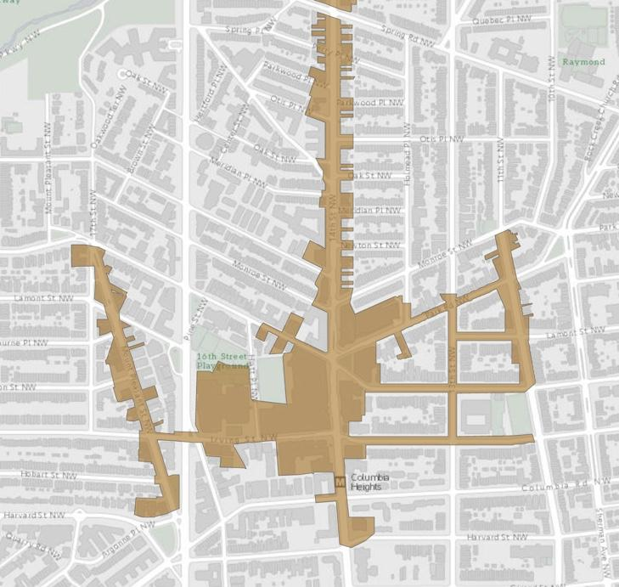
- Confirm eligibility using your business address here.

2020 APPLICATION
Columbia Heights/ Mount Pleasant Main Street Small Business Grants

Please fill out the following information and submit with your Business License.

SECTION 1. APPLICANT INFORMATION

BUSINESS (0 points)
This information pertains to the business that will benefit from the Small Business Grant.

Registered Business Name:

Trade name/DBA (if different from Registered Name):

Brief description of type of business (e.g., restaurant, book store, dentist):

Year business established:

Business Address:

Mailing Address (if different from business address):

Business Phone:

OPTIONAL: Website:

OPTIONAL: Social Media sites (Facebook, Instagram, Twitter, Yelp):

BUSINESS OWNER
This section pertains to the business owner(s) who is applying for the Small Business Grant. If there are multiple business owners, all owners must sign the Application [SECTION 5].

Business Owner(s) Name(s):

Business Owner(s) Cell Phone Number(s):

Business Owner(s) Email(s):

SECTION 2. PROJECT DESCRIPTION

PROJECT DESCRIPTION (90 points)
This section pertains to the proposed project activities for which the applicant seeks funding.

Please provide a brief summary of proposed project (no more than 300 words) (25 points):

How will the proposed project help to support your business (no more than 300 words) (20 points):

How will the proposed project help to support the community (no more than 300 words) (25 points):

Please describe how you plan to implement your project in terms of timeline, use of contractors, and any required permits or permissions (no more than 300 words) (20 points):

SECTION 3. PROJECT BUDGET

TOTAL PROJECT COSTS (10 points)
This section pertains to the proposed project costs.

Please provide a summary of costs for the proposed project, such as materials, labor, installation, etc. Each line should list the Item, Item Cost, and Source of Funding to cover the item’s cost. If the total project cost is greater than the amount requested from District Bridges’ grant, please identify the expected source of additional funding (e.g., District Bridges grant, loan, other grant, business operating funds, etc.). Feel free to include a narrative justification if applicable.

Item | Item Cost | Source of Funding
 | $
 | $
 | $
 | $
 | $
 | $
TOTAL PROJECT COST | $
Total grant request from District Bridges | $

SECTION 4. APPLICATION CHECKLIST

Please use this Checklist to confirm all required documents are included in the final application submission.

🗸 Complete responses to all questions asked in the application.

🗸 Verify your business is located within the CHMPMS boundary.

🗸 Copy of lease showing at least 2 years remaining or proof of ownership

🗸 Copy or photograph of business owner’s Business License valid in Washington, DC.
🗸 If applicant is leasing the property and proposing interior or exterior changes not allowed in the lease, please provide a signed permission from landlord allowing proposed project improvements to the property (see example, below).

EXAMPLE OF APPROVAL AND AGREEMENT BY PROPERTY OWNER(S)

As property owner(s) of _______________________________________, I/we have:
[address of commercial property]
● Reviewed the requested exterior and/or interior improvements for which my business owner tenant is applying for the District Bridges services [described in SECTION 2] of the business’s grant application.

● Agreed to allow those physical improvements to my commercial property should District Bridges approve the request for service(s).

______________________________________________________________________________________
Signature of Property Owner Signature of Co-Property Owner
(if applicable)

_____________________________________________________________________________________
Print Name of Property Owner Print Name of Co-Property Owner
(if applicable)

_____________________________________________________________________________________
Date Date
(if applicable)

SECTION 5. AGREEMENT BY BUSINESS OWNER(S)

As business owner(s) of _______________________________________, I/we have:
[name of business]

- Reviewed the District Bridges Small Business Grant Application Guidelines document that was provided with this application.
- Verified that my business is within the Main Street boundaries.
- Used the Application Checklist to ensure the application is complete upon submission.
- Understand that determination of Small Business Grant awards are at the discretion of District Bridges Selection Committee.
- Understand that I/we will have to pay the fees to obtain copies of required certifications and building permits for the proposed project. These costs are an eligible use for the District Bridges small grant if awarded.

______________________________________________________________________________________
Signature of Business Owner Signature of Co-Business Owner
(if applicable)

_____________________________________________________________________________________
Print Name of Business Owner Print Name of Co-Business Owner
(if applicable)

_____________________________________________________________________________________
Date Date
(if applicable)

